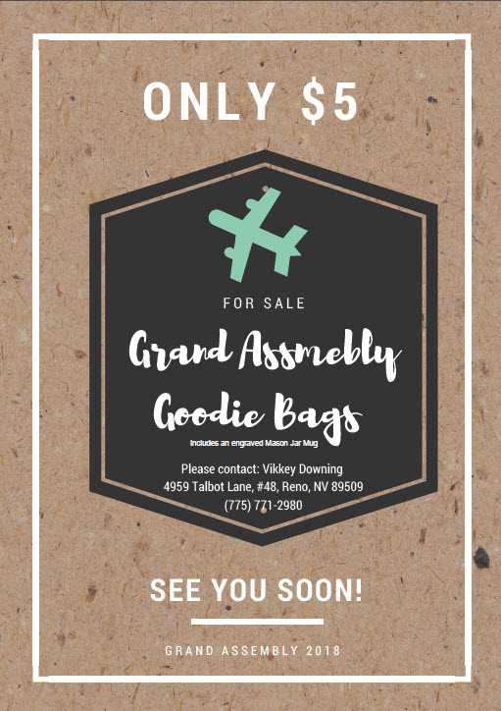
Grand Assembly Goodie Bags Order Form

Assembly _____________
Number Ordered _____________

Total Bags Ordered ________@ $5.00 each

Total Cost _________

Please send order and money to:

Vikkey Mumby
4959 Talbot Lane, #48
Reno, NV 89509
Or call: (775) 771-2980

