83rd Annual Session
Grand Assembly of Nevada
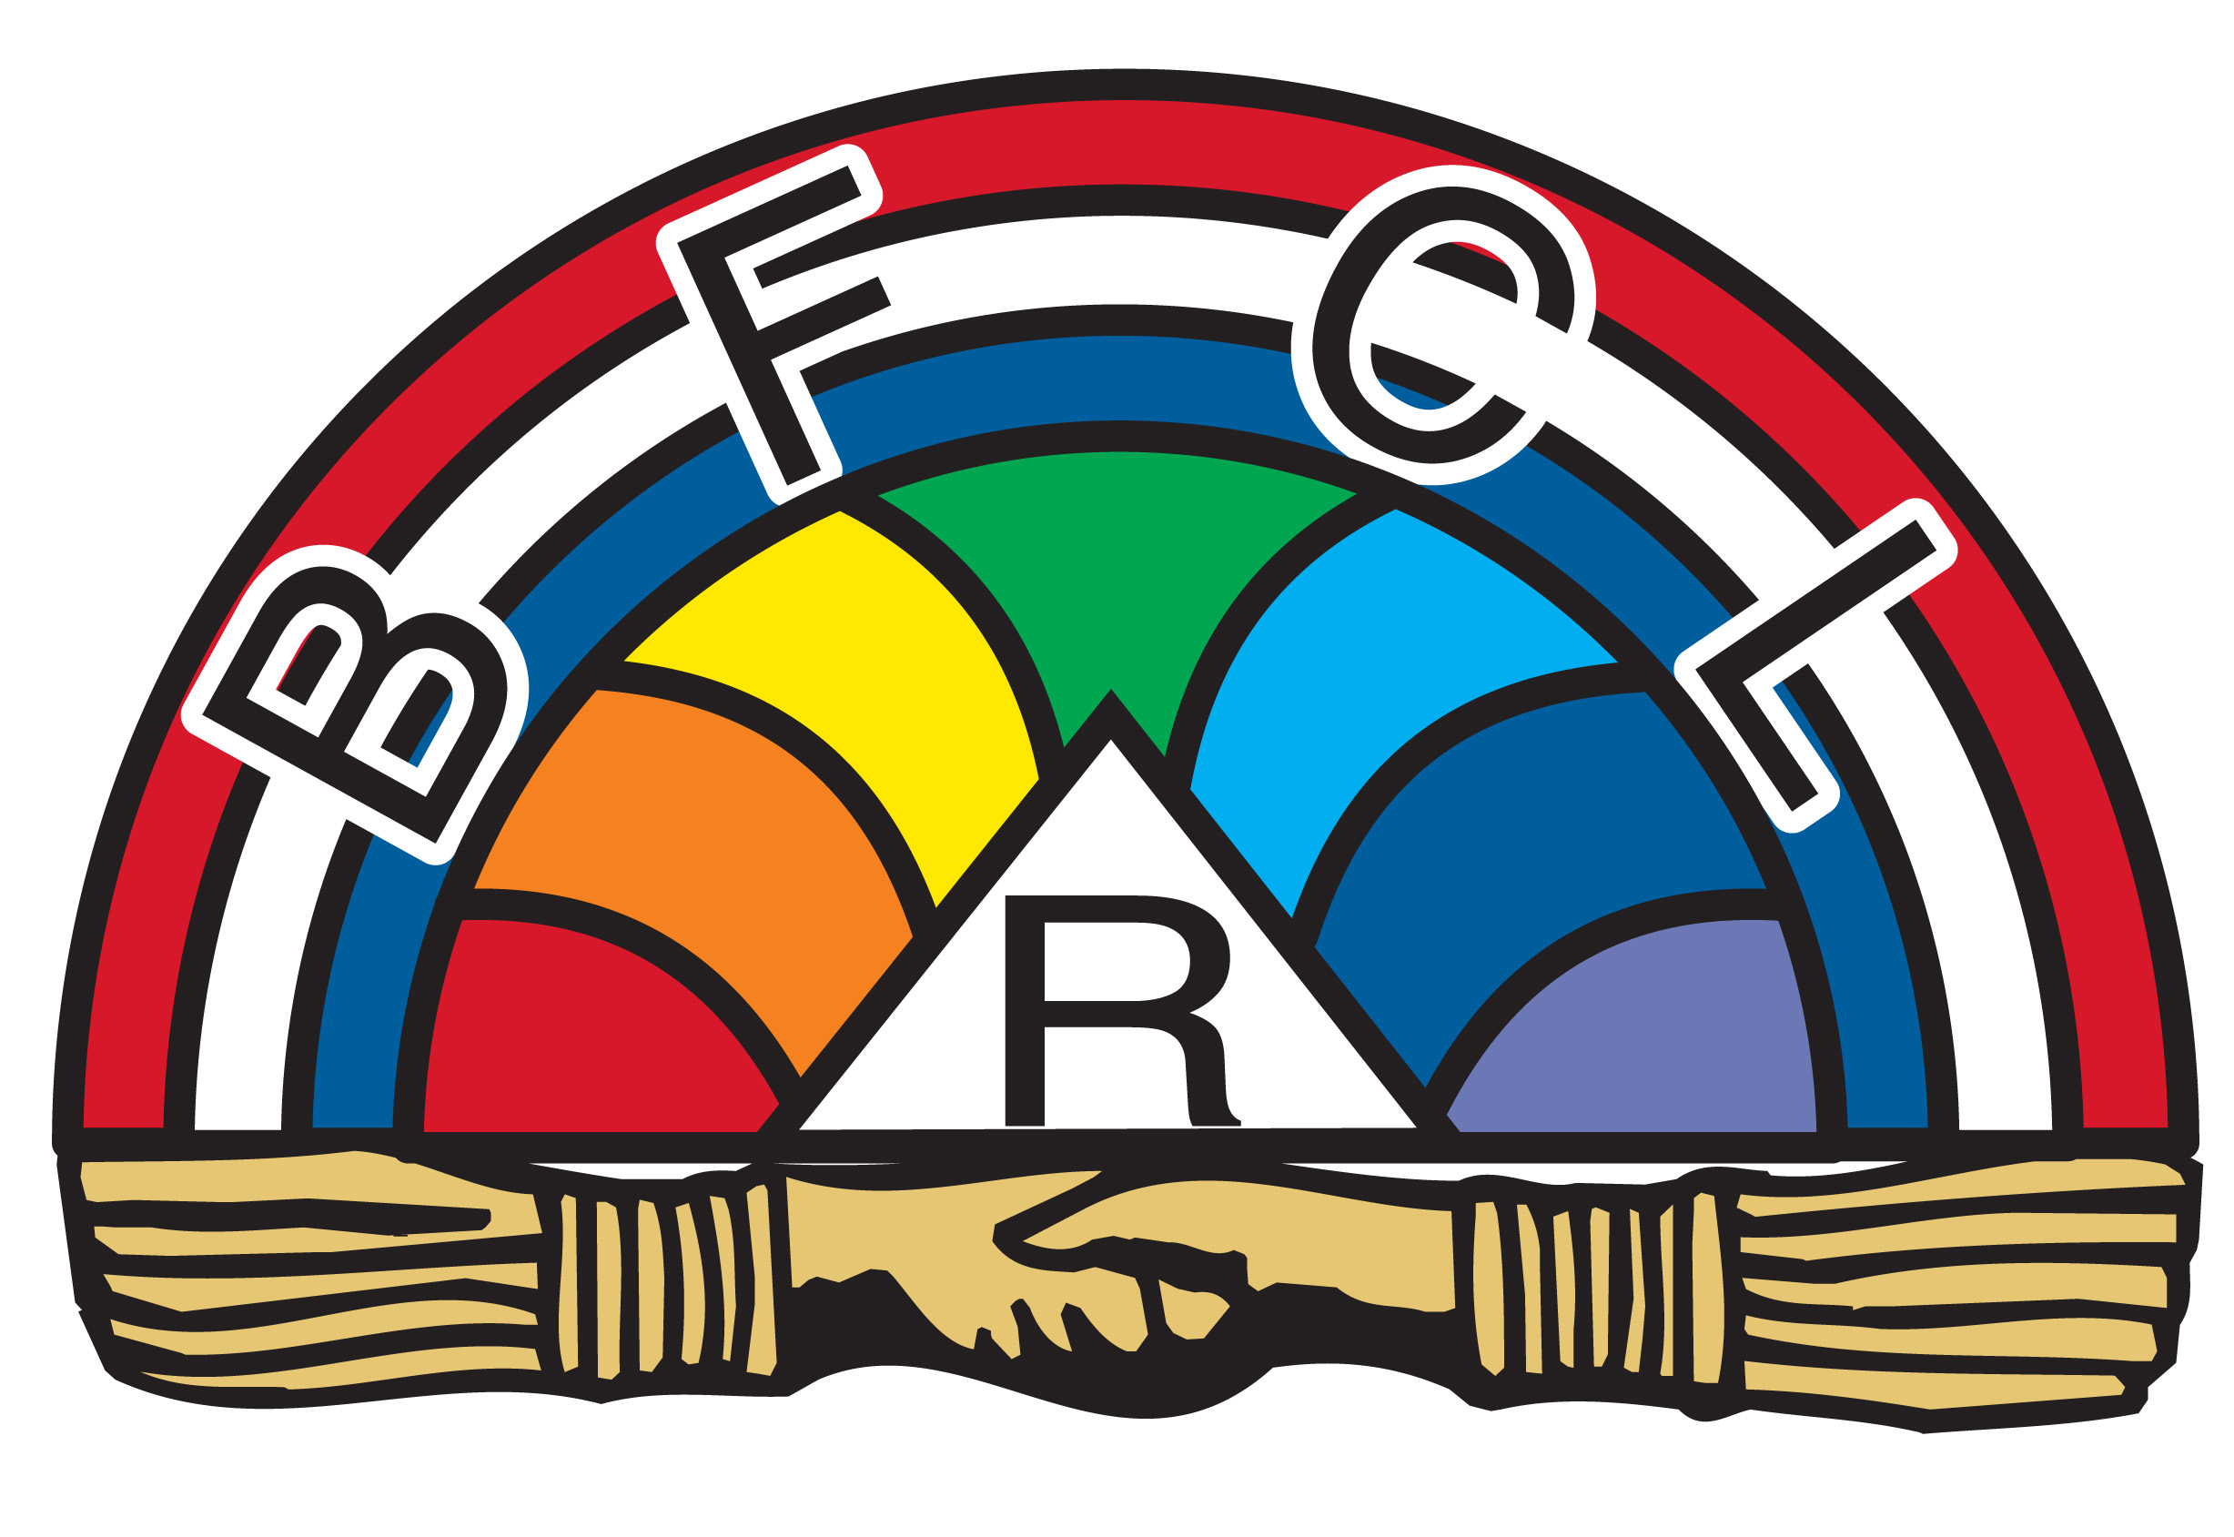
International Order of the Rainbow for Girls

“Let’s Chase the Adventure”
June 17 - 20, 2017
Peppermill Resort Spa Casino
Reno, Nevada

Important Notes:
- All Grand Assembly events, except Fun Night, occur at the Peppermill Resort Spa Casino, in the Tuscany Ballroom. The hotel phone is: 1-866-821-9996.
- A First Aid Room is available; please ask an adult in the West for assistance.
- Please be sure all cell phones and other electronic devices are turned off while in the Grand Assembly Room.
- ONLY our official photographers may take pictures during closed sessions. Flash drives (with all Grand Assembly photos) may be purchased through Grand Assembly Registration.
- Ways & Means will be open before and after each Session; Ways and Means will be closed during Sessions.
- Minor scheduling changes are inevitable in any program.

FRIDAY, June 16, 2017
- Dress check for Grand Officers, Personal Pages
- OFFICIAL PHOTO SCHEDULE
2017 Grand Officers, State Rainbow Dad, Personal Pages
- March-In practice
- Grand Officers’ Party (includes Personal Pages) – hosted by GAC

SATURDAY, June 17, 2017
Grand Assembly Registration open throughout the day.

** GRAND ASSEMBLY ROOM IS CLOSED FOR PRACTICE **
7:00 am: Breakfast Buffet (GO, Pages, Grand Deputies/Directors, SRD, SD; others if meal ticket purchased)
8:00 am: Grand Officer practice – Grand Assembly Room

12:00 pm: Practice Lunch (GO, Pages, Grand Deputies/Directors, SRD, SD; others if meal ticket purchased)
4:45 pm: Grand Cross of Color Team practice – Grand Assembly Room
5:00 pm: Fun Night! Reno Ace’s vs. Las Vegas 51’s – Aces Ballpark, Greater Nevada Field
Buses begin transportation to ballpark; buses will run continuously until all guests are transported
All you can eat BBQ (included in Fun Night event ticket)
9:30 pm: Buses begin transportation to Peppermill
1 hour following Baseball Game: CURFEW

SUNDAY, June 18, 2017
7:00 am – 8:00 am: Breakfast Buffet - if meal ticket purchased or on your own
8:00 am - 3:00 pm: Grand Assembly Registration open
9:30 am – 11:00 am: Fingerprinting and Background Checks available from Sunset Notary Services
~All ADULT workers must complete both prior to October 1, 2017~

** GRAND ASSEMBLY ROOM CLOSED FOR PRACTICE **
8:30 am - 10:30 am: Grand Choir practice – Grand Choir members, Grand Choir Director, Grand Musician and
Director of Grand Assembly Music
10:15 am: Grand Choir March-in practice with Director of Grand Officers
10:15 am: WA/PWA March-in practice with Director of Grand Officers
10:15 am: Grand Assembly Flag Bearer March-in practice with Supreme Deputy
10:30 am - 10:45 am: Vesper Service practice with Mrs. Hatfield, Grand Deputy

10:50 am: Doors to Grand Assembly Room open
11:00 am: Vespers Service - Open to Family and Friends

11:30 am: General Luncheon – if meal ticket purchased or on your own
11:30 am: Grand Cross Lunch – Masters/Designees of the Grand Cross Only
12:45 pm: Grand Cross Designates enter Temple of Silence
1:00 pm: Grand Cross Degree - Grand Assembly Room

1:30 pm – 2:45 pm: Fingerprinting and Background Checks available from Sunset Notary Services
~All ADULT workers must complete both prior to October 1, 2017~

2:30 pm: Adult Leadership Team Photo – Grand Deputies, Directors, Supreme Deputy, Adult GEB

2:55 pm: PRE-SESSION ANNOUNCEMENTS – Megan and Dylan Sakelarios, SRD, PSRDs

3:00 pm: OPENING of the 83rd GRAND ASSEMBLY of NEVADA - Open to Family and Friends
Call to Order – Shelby Brandt, Jr. PGWA
Entrance of WA/PWAs and Grand Choir
Entrance of 2017 Grand Officers and Personal Pages
Formal March-In – 2017 Grand Officers
Escort of GWA to Grand East
Welcome – Megan Sakelarios, GWA
Flag Presentations and Tributes
American Flag – Trynn Reymer, Mt. Rose #13 and Gennie Rittman Hudson, Specialist, US Army and
Past Grand Charity
Christian Flag – Ashley Lusk, Las Vegas #9 and Amanda Downing, Past Grand Representative
Nevada Flag – Maranda Templeton, Mt. Rose #13 and Logan Howell, Past Grand Patriotism
Rainbow Flag – Katherine Bailey, Las Vegas #9 and Sawyer Bernhard, Past Grand American Flag Bearer
Welcome to Grand Assembly – Mr. Torry Thompson, State Rainbow Dad
Dedication to 2017 Grand Assembly Committee – Megan Sakelarios, GWA
Introduction of 2017 Grand Officers – Megan Sakelarios, GWA
Invocation – Mr. Torry Thompson, State Rainbow Dad
Ceremony to Pledge – Grand Officers on Membership Team and Personal Pages
Pledge Presentation to GWA – Pledge Members
Rainbow Camp Report – Lesley Lechuga Gomez, GWAA
Escort - Nevada Jobs Daughters, Northern California DeMolay Association
Greetings - Youth Leaders
Miss Jessica Solon, Miss Nevada Job’s Daughter 2016-2017
Mr. Jake Eres, Past Master Counselor, Northern California DeMolay
Parents’ Ceremony and Presentation – 2017 Grand Officers
Introduction of GWA’s Family – Megan Sakelarios, GWA

4:30 pm: Open to Affiliated Members, Parents and Grandparents only (time is approximate)
Verification of Members
Grand Choir Performs “I’d Like to Teach the World to Sing”
Ritualistic Opening – 2017 Grand Officers
Formal Escort - Please retire one group in advance for escort; PGO: please retire while Grand Choir is singing
Current/Past Supreme Officers
Supreme Deputies
Current/Past/Emeritus Grand Deputies - all jurisdictions
Current Directors - all jurisdictions
Current/Past Grand Worthy Advisors - all jurisdictions
Current Grand Officers - other jurisdictions

Grand Choir Performs “Rather Be”
Past Grand Officers should retire to the West at this time for escort.
Formal Escort, continues
Past Grand Officers - all jurisdictions
NV Grand Assembly Board of Directors and Grand Executive Committee Members - all jurisdictions
Grand Assembly Committee Members - Nevada
Current/Past Was and MAs - all jurisdictions
Girls of the Year for Membership and Service in Nevada
Current/Past State Rainbow Dads in all Jurisdictions, Current Assembly Rainbow Dads in Nevada

6:00 pm: Open to Family and Friends (time is approximate)
Grand Choir Performs “Wonderful World”
NOAH Report – Mrs. Lisa Cox
Alumni Association Report – Mrs. Diane Hatfield
Grand Representative Reports
Connecticut/Massachusetts; North Dakota/Texas; Missouri/Pennsylvania; Arizona/Colorado
Assembly Entertainment
Boulder #8; Sparks #3 (Following Entertainment, assemblies may remain in costumes.)
Grand Representative Reports
South Carolina/Washington/Idaho; Maryland/North Carolina; Virginia
Remarks – Mrs. Joanie Jacka, Supreme Worthy Associate Advisor
Talent Show
Carolyn Coffman, Daylite #22; Leah Bouchard, Reno #1; Andrea Boltes, Daylite #22;
Trynn Reymer, Mt. Rose #13; Catrina Auglubat, Reno #1; Margaret Washington, Daylite #22
Grand Recorder’s Announcements – Tiffany Coulson, Grand Recorder
Presentations – 2017 Grand Officers
Proclamation – Kailynn Yetter, Grand Drill Leader
Retiring March - 2017 Grand Officers

Immediately following Session: OFFICIAL PHOTO SCHEDULE
Current/Past Grand Officer FAMILY Pictures (all G. Faiths, all G. Recorders, etc.)
7:30 pm: Dinner - if meal tickets purchased or on your own
10:00 pm: Curfew

MONDAY, June 20, 2017
7:00 am - 8:00 am: Breakfast Buffet - if meal ticket purchased or on your own
7:45 am: OFFICIAL PHOTO SCHEDULE
Assembly Group Photos – Reno #1, Sparks #3, Las Vegas #9, Mt. Rose #13, Tonopah #15

8:00 am: Grand Assembly Registration opens
8:00 am: Initiation Candidates meet with GWA, Grand Faith, and Grand Drill Leader – Grand Assembly Room
8:15 am: Grand Choir, WA/PWAs, Personal Pages, Grand Officers line up

8:30 am: Open to Affiliated Members, Parents and Grandparents only
Call to Order – Vanessa Harms Nelson, PGWA
Entrance - Grand Choir, WA/PWAs, Personal Pages and 2017 Grand Officers
Formal March In – 2017 Grand Officers
Proclamation – Kailynn Yetter, Grand Drill Leader
Pledge of Allegiance, Sing “America”
Dedication to Director of Grand Officers and 2017 Personal Pages – Megan Sakelarios, GWA
Introduction of Mother Advisor for Grand Assembly, Ms. Augusta Irvin, Mother Advisor, Carson #7
Verification of Members
Grand Choir Performs “I Don’t Wanna Be”
Initiation – 2017 Grand Officers
Introduction of Class of Initiates – Derika Ellithorpe, Grand Faith
Special Welcome to New Members - Mr. Torry Thompson, SRD
Escort, continued
Order of the Eastern Star
General Grand Chapter Members
Worthy Grand Matrons/Patrons - all jurisdictions
Past Grand Matrons/Patrons - all jurisdictions
Elected Grand Officers of the Order of the Eastern Star - all jurisdictions
Worthy Matrons and Worthy Patrons - all jurisdictions
Most Worshipful Grand Masters - all jurisdictions
Past Grand Masters - all jurisdictions
Shrine Potentate
Elected Grand Officers of the Grand Lodge - all jurisdictions
Worshipful Masters - all jurisdictions
Adult Youth Group Leaders in Nevada
Greetings – Worthy Grand Matron and Worthy Grand Patron
Greetings – Illustrious Potentate
Greetings – Most Worshipful Grand Master in Nevada
Grand Choir Performs “Small World”
Grand Recorder’s Annual Membership Report – Tiffany Coulson, Grand Recorder
Introduction of Membership Team – Megan Sakelarios, GWA
Report of Membership Team – Derika Ellithorpe, Grand Faith
Announce Girls of the Year for Membership and Assembly Membership Award – Derika Ellithorpe, Grand Faith
Recorder’s Announcements - Tiffany Coulson, Grand Recorder
Memorial Service – 2017 Grand Officers
Proclamation – Kailynn Yetter, Grand Drill Leader

** Please exit the Grand Assembly Room in silence, when dismissed by Personal Pages. **

12:00 pm: All Member Luncheon
ALL Nevada Rainbow Girls initiated since last Grand Assembly will be seated with the Membership Committee

1:30 pm: Open to Family and Friends
Grand Officers’ Pantaloon Parade
Special Entertainment
Call to Order – Carson Assembly #7
Entrance - Grand Choir, WAs/PWAs, Personal Pages, 2017 Grand Officers
Formal March In – 2017 Grand Officers
Proclamation – Kailynn Yetter, Grand Drill Leader
Welcome from the Peppermill Resort Spa Casino
Dedication to Carson and Tonopah Assemblies – Megan Sakelarios, GWA
Special Appreciation – Megan Sakelarios, GWA
State Rainbow Dad’s Report - Mr. Torry Thompson, SRD
Introduction of GWA’s Family – Megan Sakelarios, GWA
Grand Choir Performs - “Seasons of Love”
Grand Representative Reports
Oregon/International Jurisdictions; Arkansas/Maine; Kentucky/Vermont; Montana/Tennessee; Hawaii/Kansas
Introduction of Grand Choir – Carolynn Coffman, Grand Choir Director
S-T-R-E-T-C-H - to the “Chicken Dance” in honor of OUR Mrs. Margaret Kofoed, PSWA
Quotes and Mascot Clues – Megan Sakelarios, GWA
Grand Lecturer’s Message – Kailynn Yetter, Grand Lecturer
Grand Representative Reports
Alabama/New Jersey; Alaska/Indiana; Louisiana/Michigan; New Hampshire/Rhode Island
Introduction of Public Relations Team – Megan Sakelarios, GWA
Grand Assembly Awards for Assembly Scrapbooks and Assembly Fabric
Grand Historian’s Report – Brittani Snook, Historian
Representative Report, Philippines – Carolyn Coffman, Grand Choir Director
Assembly Entertainment
Las Vegas #9; Tonopah #15; Daylite #22 (Following Entertainment, assemblies may remain in costumes)
Wishing Well, Experience Raffle, Wills
Recorder’s Announcements – Tiffany Coulson, Grand Recorder
Presentations – 2017 Grand Officers
Proclamation – Kailynn Yetter, Grand Drill Leader
Retiring March – 2017 Grand Officers

4:00 pm: OFFICIAL PHOTO SCHEDULE
Assembly Group Photos – Carson #7, Boulder #8, Winnemucca #10, Ben Franklin #21, Daylite #22

5:00 pm: Grand Banquet

7:00 pm: Open to Family and Friends
Introduction of 2017 Grand Family and their Escorts
Call to Order – Jennifer Lewis, PGWA, and Melissa Teston, PG Faith
Entrance - WA/PWAs, Personal Pages and 2017 Grand Officers
Formal March In – 2017 Grand Officers
Proclamation -- Kailynn Yetter, Grand Drill Leader
Dedication to Mrs. Haartz and Mrs. Jacka – Megan Sakelarios, GWA
Recognition of Grand Officers’ Parents – Megan Sakelarios, GWA
Statewide Service Project Report and Presentation to Honor Flight of Nevada – Megan Sakelarios, GWA
Announce Girls of the Year for Service and Assembly Service Award – Megan Sakelarios, GWA
Assembly Entertainment
Mt. Rose #13; Ben Franklin #21; Reno #1 and Winnemucca #10
Grand Representative Reports
Oklahoma/Nebraska; California; Florida/New York
Tour Director Report – Mrs. Kim Butler, Tour Director
Introduction of Fund Raising Team – Megan Sakelarios, GWA
Report of Fund Raising Team – Caitlin Katzenbach, Grand Charity; Chaslynn McAllister, Grand Hope
Announce Scholarship Awards – Chaslynn McAllister, Grand Hope
Ribbon Ceremony, Kailynn Yetter, Grand Lecturer
Grand Assembly Awards for Assembly Waivers and Banners; GO Pantaloons and Mascots; Grand Choir Mascots;
Personal Page Baskets
Proficiency Awards – Mrs. Vanessa Nelson, Director of Proficiency
Relinquishing of Grand Officer Pins – 2017 Grand Officers
Announcements – Tiffany Coulson, Grand Recorder
Announcements - Mrs. Heidi Haartz, Supreme Deputy
Presentation to GWA, 2017 Grand Assembly Committee
Presentations – 2017 Grand Officers
Quotes and Mascot Clues – Megan Sakelarios, GWA
Proclamation – Kailynn Yetter, Grand Drill Leader
Retiring March – 2017 Grand Officers
Entertainment – Shelby Brandt, Jr. PGWA
Grand Officers’ PROTEST!
Announcement of 2017-2018 Grand Officers
One hour after Grand Officer Announcements: Curfew

TUESDAY, June 21, 2017
7:00 am – 8 am: Breakfast Buffet - if purchased or on your own
8:00 am: New Grand Line Officers Meeting with SD, Director of Grand Officers – Grand Recorder’s Desk

9:00 am: Open to Family and Friends
Call to Order – Joanie Jacka, Supreme Worthy Associate Advisor
Entrance - Grand Choir, WA/PWAs, Personal Pages and 2017 Grand Officers
Formal March In – 2017 Grand Officers
Proclamation – Kailynn Yetter, Grand Drill Leader
Pledge of Allegiance, Sing “America”
Dedication to 2017 Grand Officers – Megan Sakelarios, GWA
Grand Assembly Awards for Grand Representative Reports and Assembly Entertainment
Grand Treasurer’s Report – Melyssa Ebbert, Grand Treasurer
Quotes – Megan Sakelarios, GWA
Grand Choir Performs: “Singin’ in the Rain”
Grand Worthy Advisor’s Report – Megan Sakelarios, GWA

9:30 am: Open to Affiliated Members, Parents and Grandparents only
Verification of Members
Grand Choir Performs: “Life is a Highway”
Majority Degree - Majority Officers
NOAH Presentation
The “Lighter Side” of Majority – Brady Jo Willis Janes, PGWA
Presentation to GWA - GWA’s Assembly/Sister Assembly
Presentations - 2017 Grand Officers
Mileage Report – Kailynn Yetter, Grand Drill Leader
Wishing Well – Megan Sakelarios, GWA
Announcements – Tiffany Coulson, Grand Recorder
Grand Choir Performs “How Far I Will Go”
Ritualistic Closing – 2017 Grand Officers

Immediately following Ritualistic Closing - Open to Family and Friends
Retiring of Jewels – 2017 Grand Officers
Rainbow Prayer, Rainbow Dreams, Grand Officers’ Circle – 2017 Grand Officers

Immediately following Session:
Installation Practice for Installing Chaplain with Director of Grand Officers
Mother Advisors meet with GEB to pay 2017-2018 Grand Officer and Grand Choir Fees – Grand Recorder’s Desk

12:00 pm: Luncheons - if meal ticket purchased or on your own
Grand Officers’ Lunch - 2017 and 2018 Grand Officers
NOAH Lunch and Annual Meeting
Gentlemen’s Lunch – 2017 and 2018 SRD, PSRDs, other gentlemen if meal ticket purchased
GWA Mom Lunch - New GWA’s Mom with PGWA Moms

Immediately following Grand Officers’ Lunch: Installation Practice for 2018 Grand Officers and Installing Officers

OFFICIAL PHOTO SCHEDULE
4:00 pm: Individual Photos of 2018 Grand Officer, Grand Deputies, Directors, Grand Executive Board (adults)
4:20 pm: Group Photo of 2018 Grand Officers, State Rainbow Dad, Supreme Deputy
4:35 pm: Individual Photos of girls serving as Worthy Advisor June 2017 – May 2018

5:00 pm: Grand Installation - Open to Family and Friends
Welcome - Alyssa Ball, PGWA, and Rebekah Bolshazy, PGWAA
Installation of Grand Officers and Grand Representatives – Installing Officers
Crowning Ceremony - Past State Rainbow Dads in Nevada
Presentation of GWA Jewel – Megan Sakelarios, Jr. PGWA
Presentation of Jr. PGWA Jewel – The Haartz and Sakelarios Family
Presentations to 2018 Grand Worthy Advisor – 2018 Grand Officers, GWA’s Assembly and Sister Assembly
Remarks - Mrs. Heidi Haartz, Supreme Deputy
Address of the GWA – 2018 Grand Worthy Advisor
Rainbow Prayer, Rainbow Dreams, Grand Officers’ Circle – 2018 Grand Officers
Closing of the 83rd Grand Assembly of Nevada

11:00 pm: Curfew

